**Internet Search Murder Mystery Starter**

**Scenario:** *A group of Hackers have been gathered together at An Anonymous Place for a Meeting about their next target. On the first night there is a murder and the butler is killed! ROBLOX Admins have been called and the Inspector has been given the following clues to identify the Exploiter. Using these clues and the Internet can you work out who did the evil deed?*

**Clues**

* *The Hacker the letter M somewhere in their real name.*
* *The murderer did not appear in the movie “Bus Stop”.*
* *The murderer was not born in Stockwell.*
* *The murderer did not appear in the movie “Blood on the Sun”.*
* *The murderer was not born in the month of April.*
* 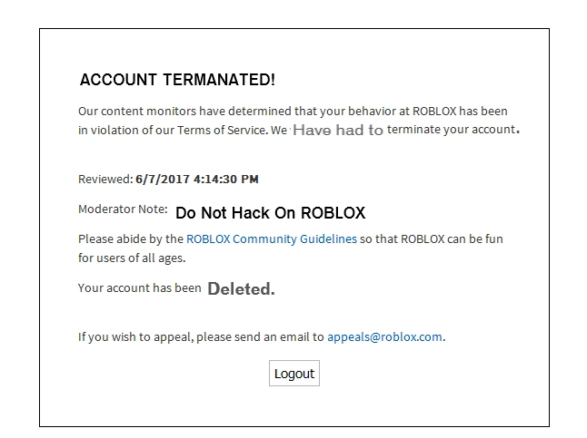

|  |  |
| --- | --- |
| *List Of Hackers* | ***Check to*** ***suspect*** |
| James Stewart |  |
| David Tennant |  |
| Marilyn Monroe |  |
| James Cagney |  |
| Spencer Tracy |  |
| Roger Moore |  |
| Engelbert Humperdinck |  |
| David Bowie |  |

**The name of the murderer is:** _____________________